

INDIVIDUAL ASSIGNMENT

Sri Lanka

COMP40004

**WEB DEVELOPMENT AND OPERATING SYSTEMS-1**

**CF2261COM**

HAND OUT DATE: 2nd week

HAND IN DATE: ASSIGNMENT2: 16th Sep 2022

ASSIGNMENT3: Week 18

WEIGHTAGE: ASSIGNMENT 2: 30% ASSIGNMENT 3: 30%

**INSTRUCTION TO CANDIDATES:**

1. **Students are advised to underpin their answers with the use of references (cited using the Harvard Name System of Referencing).**
2. **Late submission will be awarded zero (0) unless Extenuating Circumstances (EC) are upheld.**
3. **Cases of plagiarism will be penalized**
4. **Assignment presentation should be submitted in the form of softcopy and hardcopy both; modeling work should be submitted in softcopy form**

**Web application to showcase “Tea industry in**

Sri Lanka”

Kavishka Ekanayake

Submitted to the Computing School in partial fulfilment of the requirements for the

Degree of

Bachelor’s of Engineering in

Software Engineering

Supervised By: Ms. Valuka Wijayagunawardene

Staffordshire University January 2022, Kandy

Acknowledgement

I am over helmed in all humbleness and gratefulness to renowned my depth to those who have helped me position these thoughts well above the level of simplicity and into something concrete. I want to express my unique thank you gratitude to my lecturer who gave me the possibility to do that excellent website venture, which also helped me in doing several Research, and I got here to realize approximately such a lot of new matters. I am, in reality, grateful to them.

Any strive at any level cannot be satisfactorily finished without my parents’, and friends' support and guidance.

I want to thank my parents, who helped me accumulate one-of-a-kind information, amassing records and guiding me in making this assignment. Despite their busy schedules, they gave me different ideas for making this mission specific.

Table of Contents

Acknowledgments……..…………………………………………………………………….…. vi

Declaration…………………..…...…………………………………………………………………... iii

Table of Contents……………………………………………………………………..………… vii

**CHAPTERS--------------------------------------------------------------------------------------**

**1.) Introduction…………………………………………………………………**

**2.) Wireframes (Screenshots)…………………………………………………..**

*3.1) Mobile version*

*3.2) Desktop version*

**3.) Overview of Website………………………………………………………...**

**4.) Conclusion………………………………………………………….**

*4.1) Problems and solutions*

*4.2) summary*

**5.) References…………………………………………………………………….**

# 

# CHAPTER 1

**1.1** Introduction

Client web Application for “Tea industry in Sri Lanka” created using HTML and pure CSS. Following hierarchy diagram (fig1.1.1) shows the basic overview and the arrangement of the client based website.

Application

Home Page

Tea plantations of Sri Lanka

By products of Tea

CSS Design 1 for a selected Tea seller 1

Tea sales

CSS Design 2 for a selected Tea seller 2

Purchase and

Donate page

Ceylon Tea Museum

(fig1.1.1)

‘’Home page” and “Tea plantation” page is created according to a same CSS style and “Ceylon tea Museum” page and “By products” page is created using a different CSS style. But in the final outcome of the website, it carries an emanated flow from the website. (Smooth flow without any bugs or code crashes).

# 

# 

# CHAPTER 2

**2.0** Wireframes for the designs

3.1 Mobile version

**Home page**

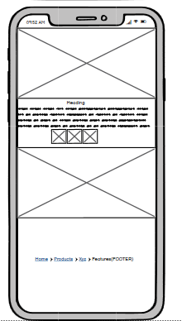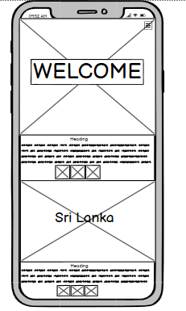

3.2 Desktop version

**Home page**

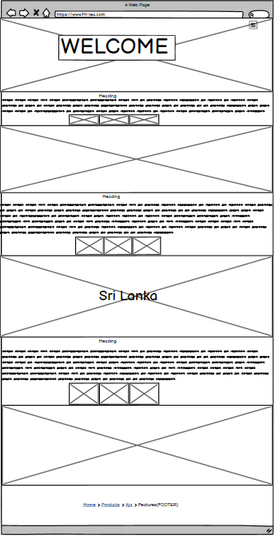

# CHAPTER 3

**5.0** Overview of the website

5.1 web design

In the closing years, a superb number of researchers have made efforts to set up which factors may lead to the achievement of an internet site. In this sense, the advertising literature has careworn the users’ factor of view to outline how an e-trade website ought to be for being a hit. In general terms, and the context of electronic trade, a successful website “draws customers, makes them sense the web site is truthful, dependable, and dependable and generates purchaser delight.”

So, an incredible element of the literature remarks on the relevance of factors such as a suitable look, the easiness of navigation, the ease of use, the protection and privacy or the content material and statistics. These elements are determinants of purchasers' behavior and the internet site fulfillment inside the e-commerce context. However, it appears extremely good the relative loss of consensus in the literature is approximately how those factors must be controlled. Consequently, expanding a chain of recommendations seems necessary to lay out interfaces that fulfill the customers' and agencies' wishes.

Nevertheless, it seems reasonable to propose that there is not a unique optimal design since it depends on the type of product commercialized, the type of user in front of the screen, or even the geographic location where the website is being visited. All these factors could determine the success of a given website. In general terms, users are more predisposed to visit and purchase well-designed websites, but there are different combinations which could lead to the creation of an optimal design.

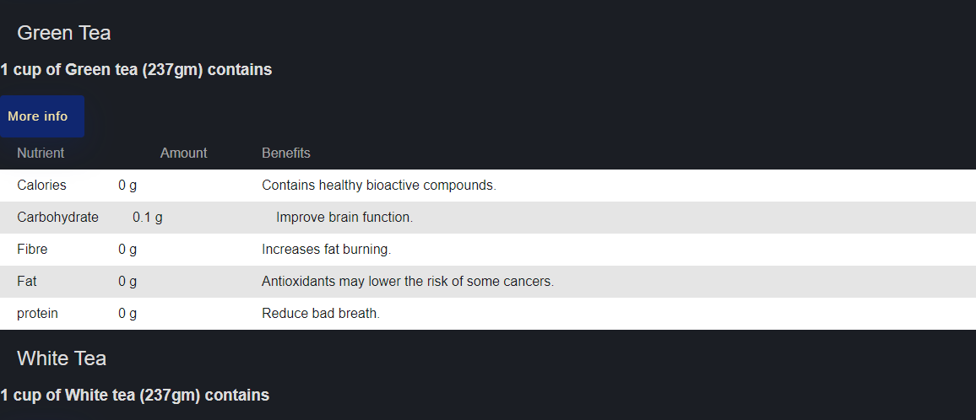5.2 div table

.2 div table

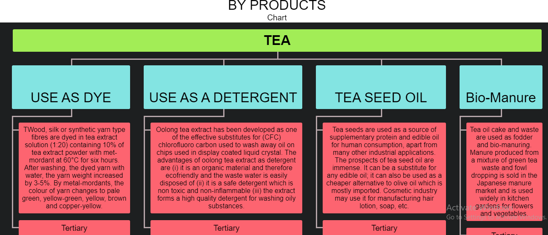5.3 HTML and CSS chart

5.3 HTML and CSS chart

5.4github link

# CHAPTER 4

* 1. **Conclusion**

4.1 problems and solutions

|  |  |
| --- | --- |
| PROBLEM | SOLUTION |
| 1.) Margin or padding for images not working due to webkit command. | Using transition command to align images without gaps and automatically responding ability for width and height. |
| 2.) Navigation-bar animation not responsive for media quarries. | Problem occurred due to the advance transition in the body. Adding a new styled navigation-bar for max-width (1000px) with a new style solved the problem. Main navigation-bar design will hide for mobile version. |
| 3.) Parallax used in Home page creates a code crash and block height.(due to the overflow command) | Increasing the height of paragraph increased the size of the div class. |
| 4.) Problem in inserting images in div classes in Homepage. | Images are inserted inside the paragraph so the html page can maintain its flow without any bugs because CSS of paragraph is smooth. |
| 5.) Div. table in “Tea-plantations” page showed a hover animation error due to the animated image gallery below it. | By div. classes in Parallax slide show, image gallery and table was divided into two parts to remove the unnecessary animation. |
| 6.) Background videos not working. | Used <video> syntax and <source> syntax to create a div. class and changed z-index to -999. |

4.2 Executive summary

The psychology of net layout consists of how colors, spacing in the design and even typeface can affect a viewer's mood. These factors come into play together with emotional factors in net design to provide visitors with positive impressions and feelings approximately your business and product. This internet design has tried to attain the level of that hues via using managed contrast snapshots, and every internet layout has a completely unique but interconnected waft.

People reply higher once they experience things that are directed to them specifically. The benefits of personalization in virtual advertising apply to websites. Personalized content that speaks without delay to customers - using the word "you," for example - and discusses their unique regions of the hobby gives many purchasers a superb, pleasant feeling that builds trust in the tea logo. This tea internet site will fulfill that region of the purchaser to a positive extent because outside libraries and JAVA scripts aren't allowed.

As newspaper and magazine publishers learned long in the past, readers tend to scan pages in a “Z” pattern. In that manner, the maximum important factors of a site should be at the upper left, center, and bottom right of a page. It’s how we as humans are stressed out to study, so the websites we build should accommodate those notion patterns. This website suits the above necessities because all the contents are divided into separate div. Lessons. These methods are included in this internet design to the most level it can be.